**IMPORTANT CAMP INFORMATION**

|  |
| --- |
| **CAMP PURPOSE** |
| The activities run at Camp Fairbairn are an engaging tool for providing teaching and learning around our camp philosophy ‘*Building Success through Challenge & Teamwork*’ and our camp curriculum, which has been derived primarily from two of the Australian Curriculum General Capabilities, these being ‘Critical and Creative Thinking’ and ‘Personal and Social Capabilities’.  The core purpose of Camp Fairbairn is to provide students with the opportunity to have learning experiences that present challenges in a team-oriented environment, thereby fostering personal growth and the development of the life skills described by these General Capabilities.  The skills outlined in these General Capabilities are relevant to the content descriptions and achievement standards of HPE as well as other subject areas. |
| **HOW MANY ADULTS TO BRING** |
| * You will need to bring a minimum of one teacher/adult for each activity group. * If your students are primary school age or have medical needs you may need to consider bringing extra adults to help with supervision. * Based on the size of your group, consider whether you already have enough adults for doing meal preparation, or whether you need an extra adult helper or two for this role (we recommend having one or two adults in charge of the kitchen for duration of camp). * School chaplains, ancillary staff, guidance officers, parents, or adopt-a-cops are great to bring along to help at camp. * Adults on camp are charged for meals but not for accommodation. |
| **FOOD** |
| * Pre-set menu options have been designed to provide variety and the easiest meal prep for the first and last day of your camp. Alternatively you can choose your own meal menu. * Your school will be in charge of prepping and serving all meals, and cleaning up afterwards. * All students and adults must bring their cutlery, crockery and tea towel. * **The provisioning order form must be returned to CFOEC** **no later than Monday the week before your camp is due to arrive**. |
| **MEDICAL** |
| * The medical synopsis forms are to be completed for BOTH staff/adults and students. * It is recommended that tetanus vaccinations are up-to-date. * Administering of any medications (other than first aid) is the responsibility of your school during camp according to departmental policy. * **The medical synopsis forms must be returned to CFOEC no later than Monday the week before your camp is due to arrive.** |
| **SUN SAFETY** |
| * CFOEC requires all students to follow the sun safety guidelines during camp or they will not be allowed to participate in the activities: * Wide brimmed hat/bucket hat (**caps are not acceptable**) * Closed-in shoes (**thongs & crocs are not acceptable**) * Sunscreen * Water bottle * Sleeved shirts (**singlets/sleeveless shirts are not acceptable**) * For high challenge activities, longer shorts/pants are recommended to make the harness more comfortable. * For water activities, clothes that can get wet are to be worn over togs and wet shoes (old sneakers or aqua shoes) are required. |
| **CAMP PROGRAM ACTIVITIES** |
| * Your camp coordinator will design and negotiate an activity program which aims to give students a variety of age-appropriate activities that align with your camp objectives. * Activities at camp are run over a Morning session 8.30am-12pm, and an Afternoon session 1pm-4pm. * Morning and afternoon tea breaks are taken at times deemed suitable to the activity by your CFOEC instructor. * A brief outline of activities and risk assessments for each activity are available under the ‘Programs and Activities’ tab on our website ([www.campfairbairnoec.eq.edu.au](http://www.campfairbairnoec.eq.edu.au)) and are based on the current CARA guidelines. |
| **FREE TIME (AFTER HOURS) ACTIVITIES** |
| * After-hours activities are the responsibility of your school. A risk assessment is required before running these activities and is also the responsibility of your school. * Some ideas for activities: * Campfire (CFOEC will provide the wood and can light the fire. Students are not to search for their own wood in the bush.) * Night walk with torches * Games on the oval (BYO equipment, we provide some footballs) * Volleyball or basketball using our facilities * Talent show/charades/or other indoor games * Formal dinner * Movie night * There is an activity hall which can be used for after-hours activities but this may need to be shared if there are multiple camps in at a time. * Both the dorm kitchen and the activity hall have a TV & DVD player. |
| **COST** |
| * You can use the cost calculator below to work out your total CFOEC cost and a per student cost. When entering your numbers use either overnight camp if you are staying at camp, or day visit if just coming for the day. * You can also refer to our Camp Menu Options form for prices. * Please note you will also need to consider transport costs |

**CFOEC Camp Cost Calculator**

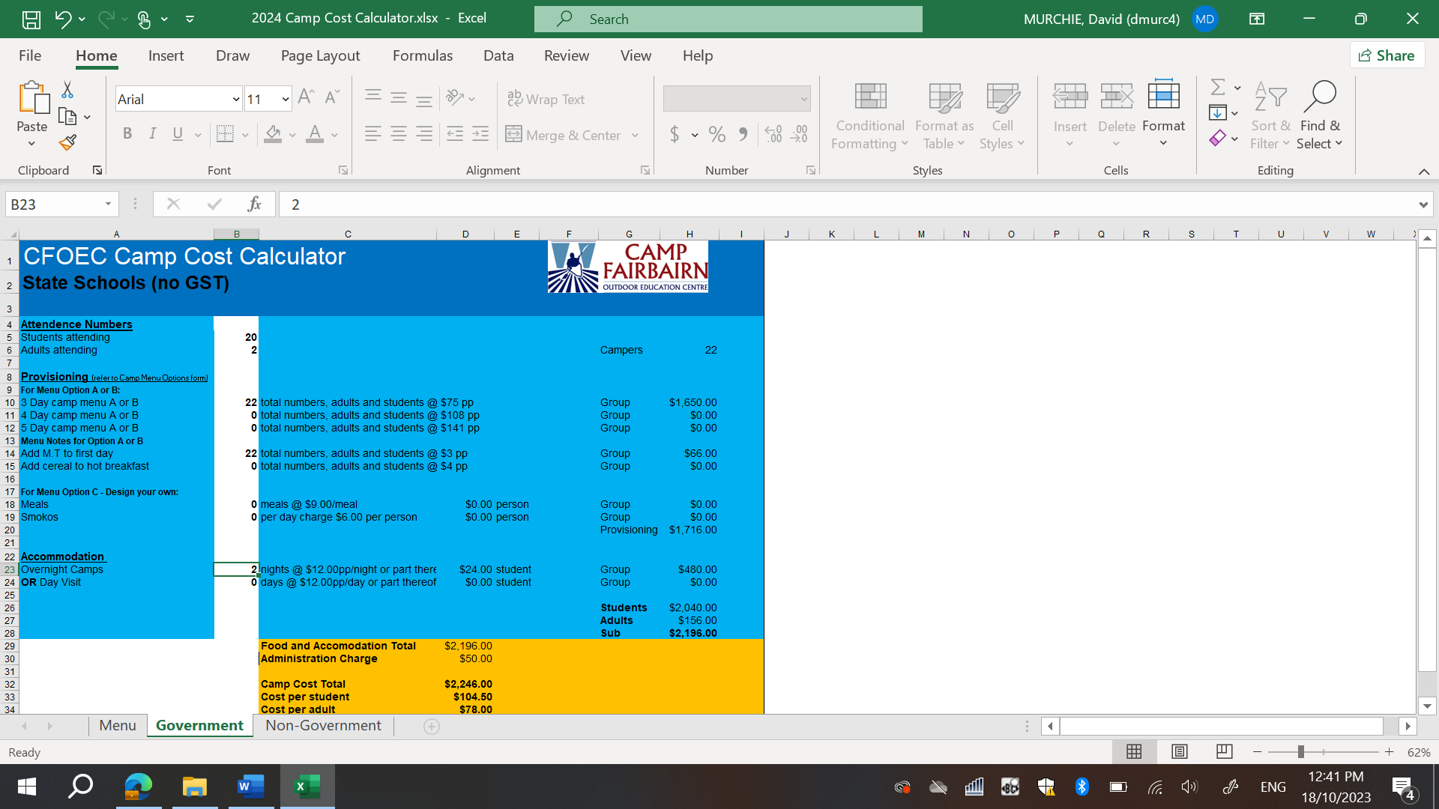



**Double click the Excel icon to open.**